Extended Abstract Template: Type Your Innovation Title Here for Virtual International Innovation Competition

First Innovator¹, Second Author², Third Author¹*
¹School / Department / Institution / Organisation, City, Country
²School / Department / Institution / Organisation, City, Country
*Email: CorrespondingAuthor@gmail.com, phone +60-778 0000

Project Summary— This document gives formatting instructions for authors preparing extended abstracts in Microsoft Word for publication in the program and proceedings for MJIC 2027. The extended abstract must be ONE (1). Type your project summary approximately 120–180 words. Briefly explain the problem or need, the innovation developed, how it works, how it was tested or evaluated, the main result or evidence, and its potential impact. Type your project summary here. Replace this sample text with your own summary.
- Introduction
This should make it relatively easy for extended abstracts submitted to be modified to form either a final MJIC 2027 proceedings paper. An electronic copy of this template can be downloaded from the conference website https://nanoscitech.uitm.edu.my/index.php. If you have questions, please contact the conference organizers.
Only online submission via the google form (https://forms.gle/YGsmyfRA4ogfNPZx5) will be accepted, NO LATER THAN 23:59 (Malaysia Time) Thursday, October. 1, 2026. The extended abstract submission (ONE Pages ONLY).
- Problem / Need
Explain who experiences the problem, where it occurs, and why it matters. Type your text here. Type your text here. Include observations, measurements, user feedback, stakeholder feedback, or other evidence where available.
- Page Layout
Do not edit the header or footer of the document. Page numbers will be inserted later.
- Objective
Type one to three clear objectives here in Arial 10 pt. Example: to develop the proposed innovation; to evaluate its performance or effectiveness; and to compare the outcome with an existing method, benchmark, requirement, or user expectation.
- Method
Explain how the innovation was developed, tested, validated, or improved. Type your text here. Type your text here. Testing may include laboratory or field tests, performance measurements, user feedback, comparison with a benchmark, or repeated trials.
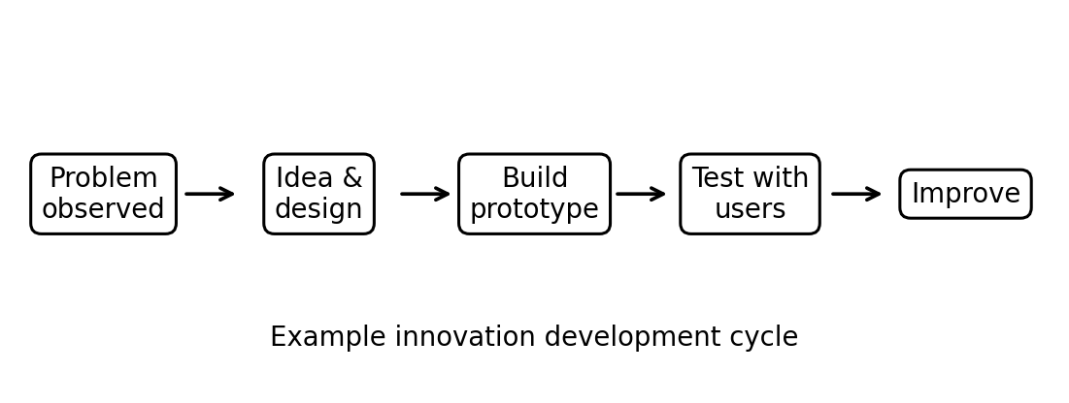
Fig. 1 Example of an unacceptable low-resolution image
- Result / Innovation Output
Show that the innovation works or has potential. Include measurements, comparisons, user feedback, photographs, tables, charts, or other appropriate evidence.
TABLE I
Font Sizes for Papers
Font Size | Appearance (in Time New Roman or Times)
Font Size | Regular | Bold | Italic
8 | table caption (in Small Caps), figure caption,  reference item |  | reference item (partial)
9 | Contact author email address (in Courier), cell in a table | abstract body | abstract heading (also in Bold)
10 | level-1 heading (in Small Caps), paragraph |  | level-2 heading,  level-3 heading,  author affiliation
11 | author name
24 | title
- Conclusions
This template is partly based on the IEEE extended abstract template.
Acknowledgment
The heading of the Acknowledgment section and the References section must not be numbered.
References
- S. M. Metev and V. P. Veiko, Laser Assisted Microtechnology, 2nd ed., R. M. Osgood, Jr., Ed. Berlin, Germany: Springer-Verlag, 1998.

